1NF
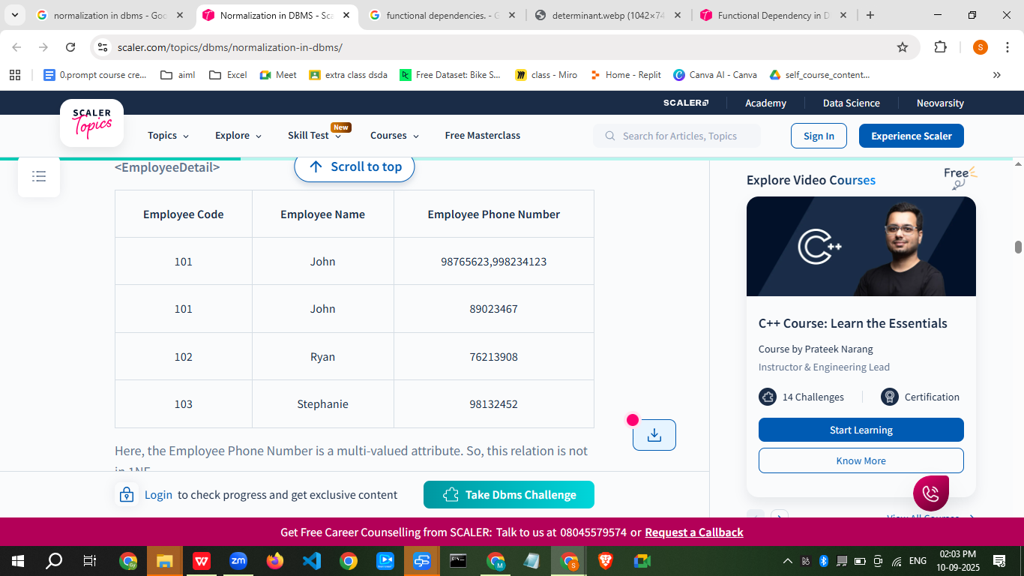

Second Normal Form (2NF)

For a relational table to be in second normal form, it must satisfy the following rules:

The table must be in first normal form.

It must not contain any partial dependency, i.e., all non-prime attributes are fully functionally dependent on the primary key.

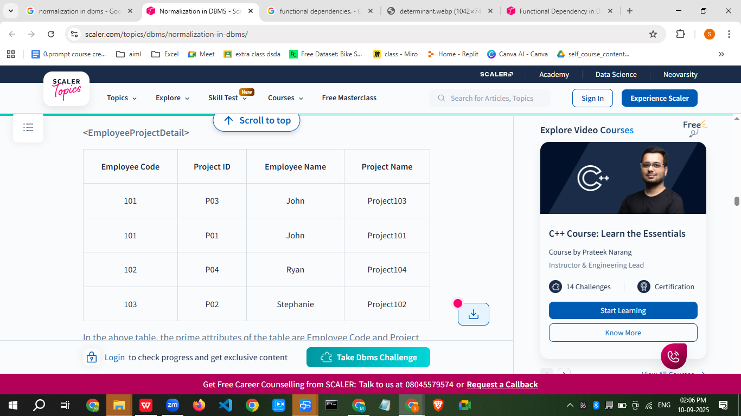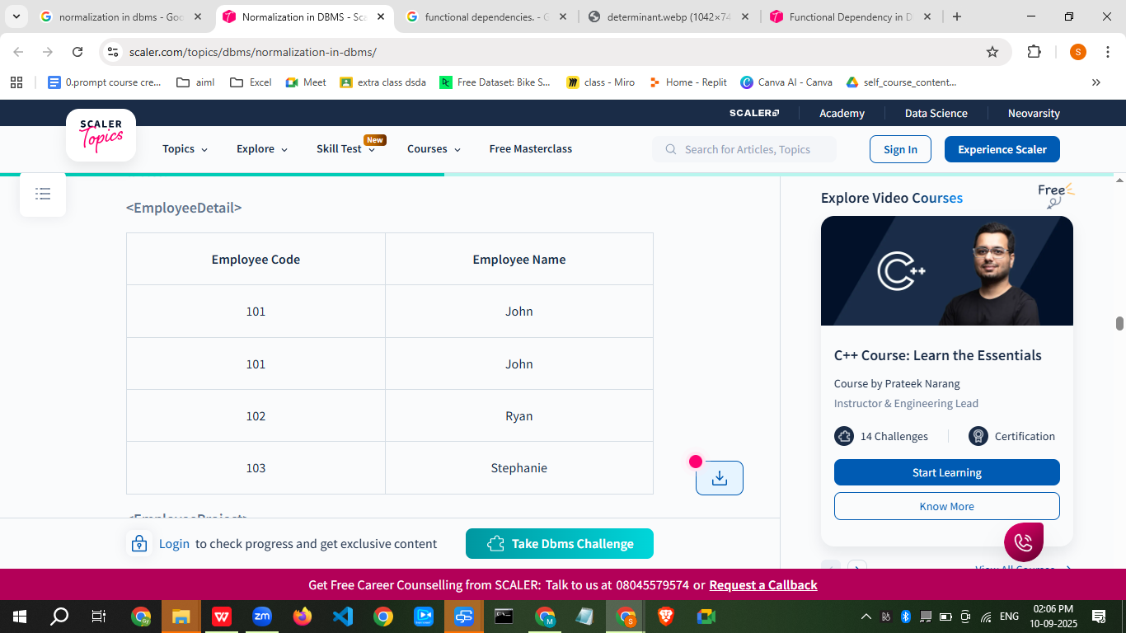
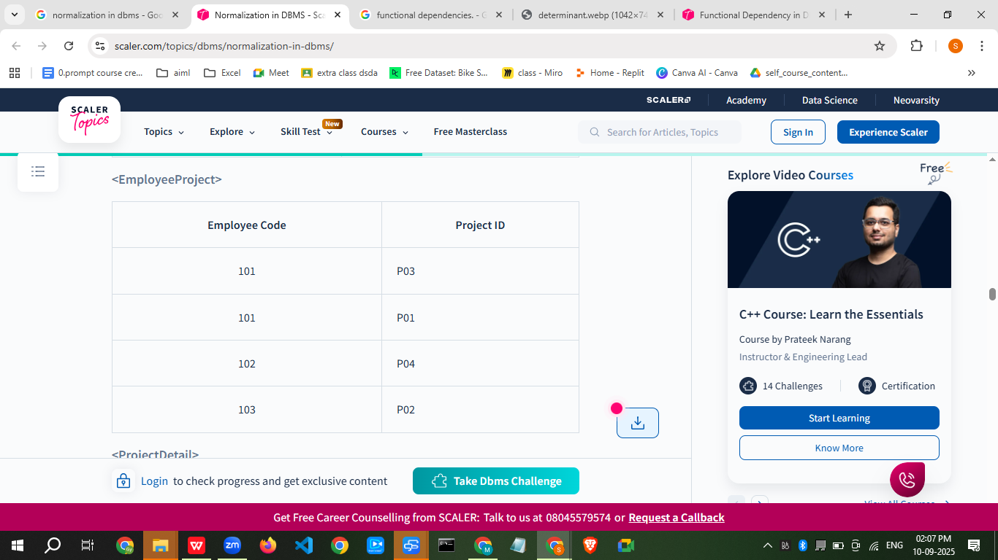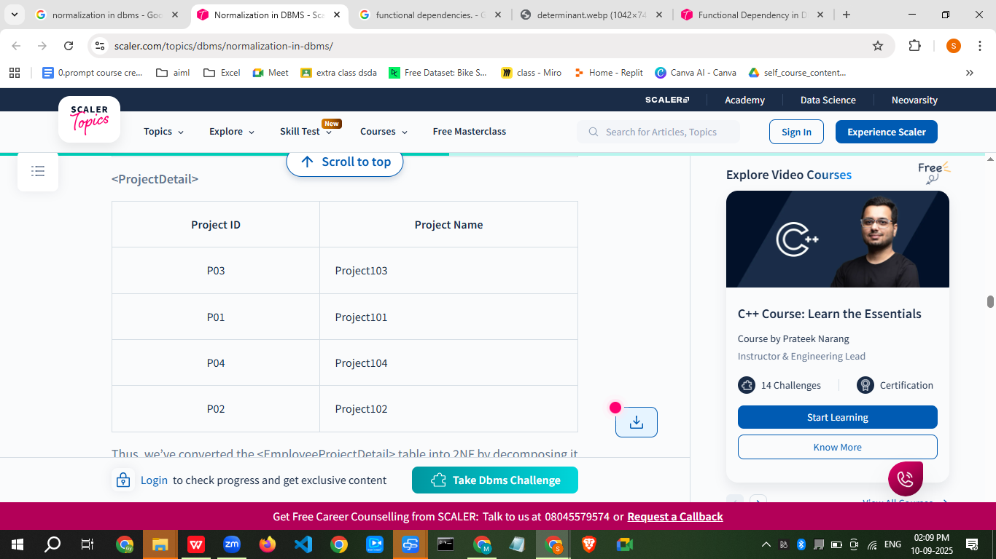

Third Normal Form (3NF)
The normalization of 2NF relations to 3NF involves the elimination of transitive dependencies in DBMS.
A functional dependency X -> Z is said to be transitive if the following three functional dependencies hold:
- X -> Y
- Y does not -> X
- Y -> Z
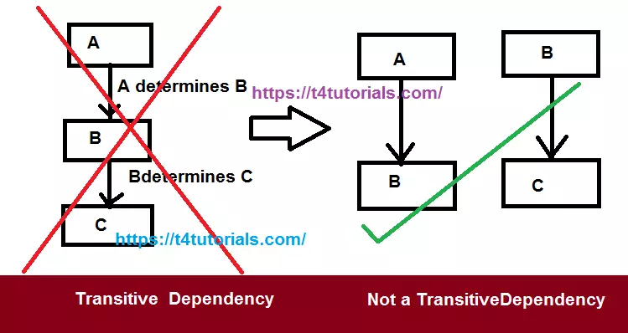

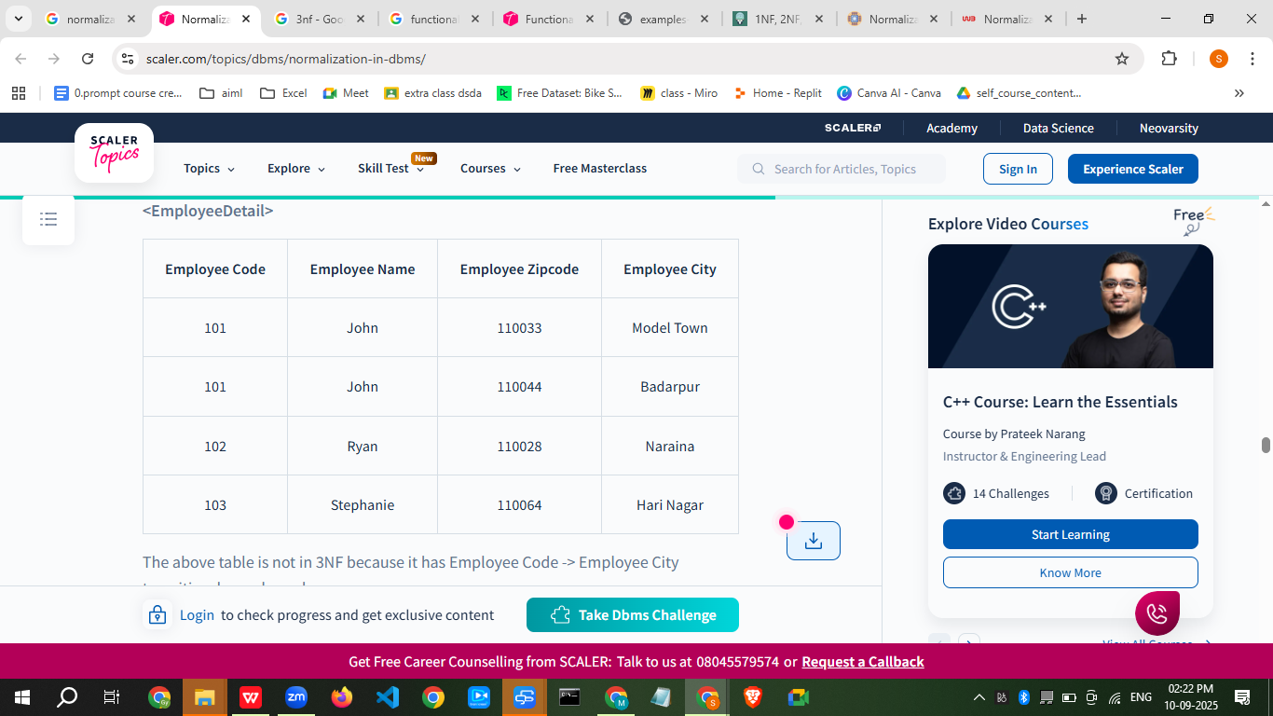
The above table is not in 3NF because it has Employee Code -> Employee City transitive dependency because:
- Employee Code -> Employee Zipcode
- Employee Zipcode -> Employee City
Also, Employee Zipcode is not a super key and Employee City is not a prime attribute.
To remove transitive dependency from this table and normalize it into the third normal form, we can decompose the <EmployeeDetail> table into the following two tables:
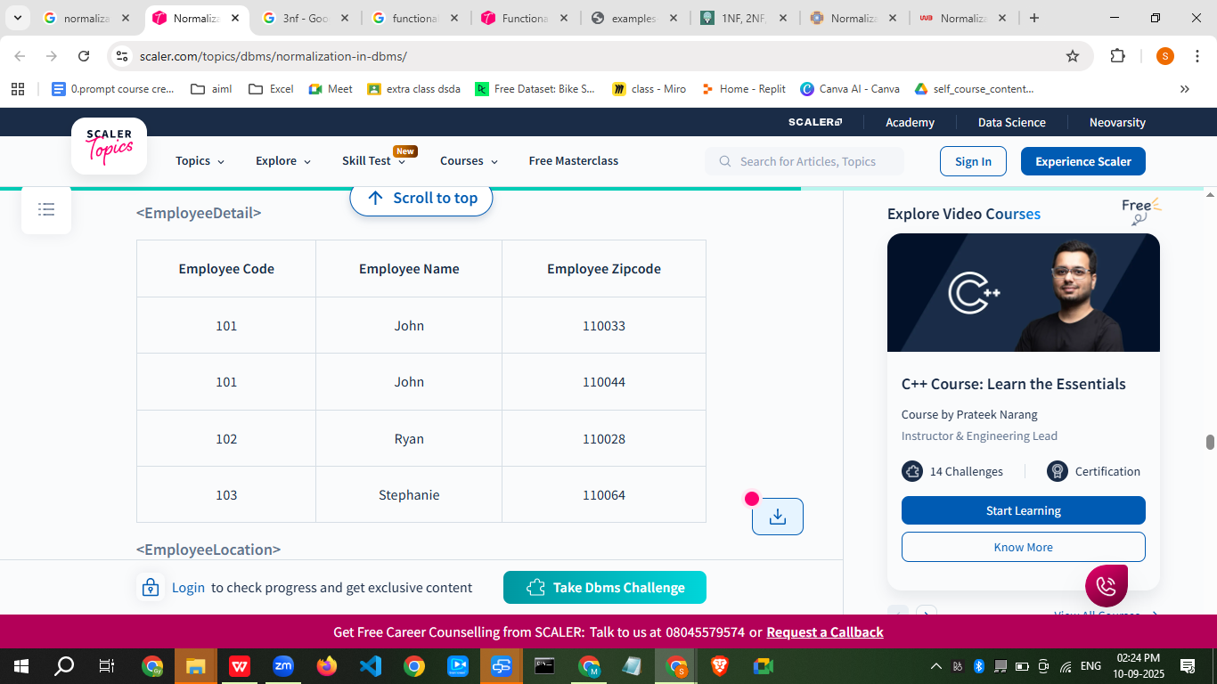

Boyce-Codd Normal Form (BCNF)
Boyce-Codd Normal Form(BCNF) is an advanced version of 3NF as it contains additional constraints compared to 3NF.
For a relational table to be in Boyce-Codd normal form, it must satisfy the following rules:
- The table must be in the third normal form.
- For every non-trivial functional dependency X -> Y, X is the superkey of the table. That means X cannot be a non-prime attribute if Y is a prime attribute.
A superkey is a set of one or more attributes that can uniquely identify a row in a database table.
Let us take an example of the following <EmployeeProjectLead> table to understand how to normalize the table to the BCNF:
<Employ


The above table satisfies all the normal forms till 3NF, but it violates the rules of BCNF because the candidate key of the above table is {Employee Code, Project ID}. For the non-trivial functional dependency, Project Leader -> Project ID, Project ID is a prime attribute but Project Leader is a non-prime attribute. This is not allowed in BCNF.
To convert the given table into BCNF, we decompose it into three tables:
<EmployeeProject>


Thus, we’ve converted the <EmployeeProjectLead> table into BCNF by decomposing it into <EmployeeProject> and <ProjectLead> tables.

